Course: ICSI 424/524

Student : Seoyeon Choi

1.Initially, log in as seed. Create a group called project1, and add seed to this group. You need to restart your system to ensure that the system recognizes your updated group membership. Verify the membership using command id.

create group named project1

-> sudo addgroup project1

add seed to project1 group

-> sudo usermod -a -G project1 seed

I restarted system to make sure my system recognizes the group and user.

I used id as command line

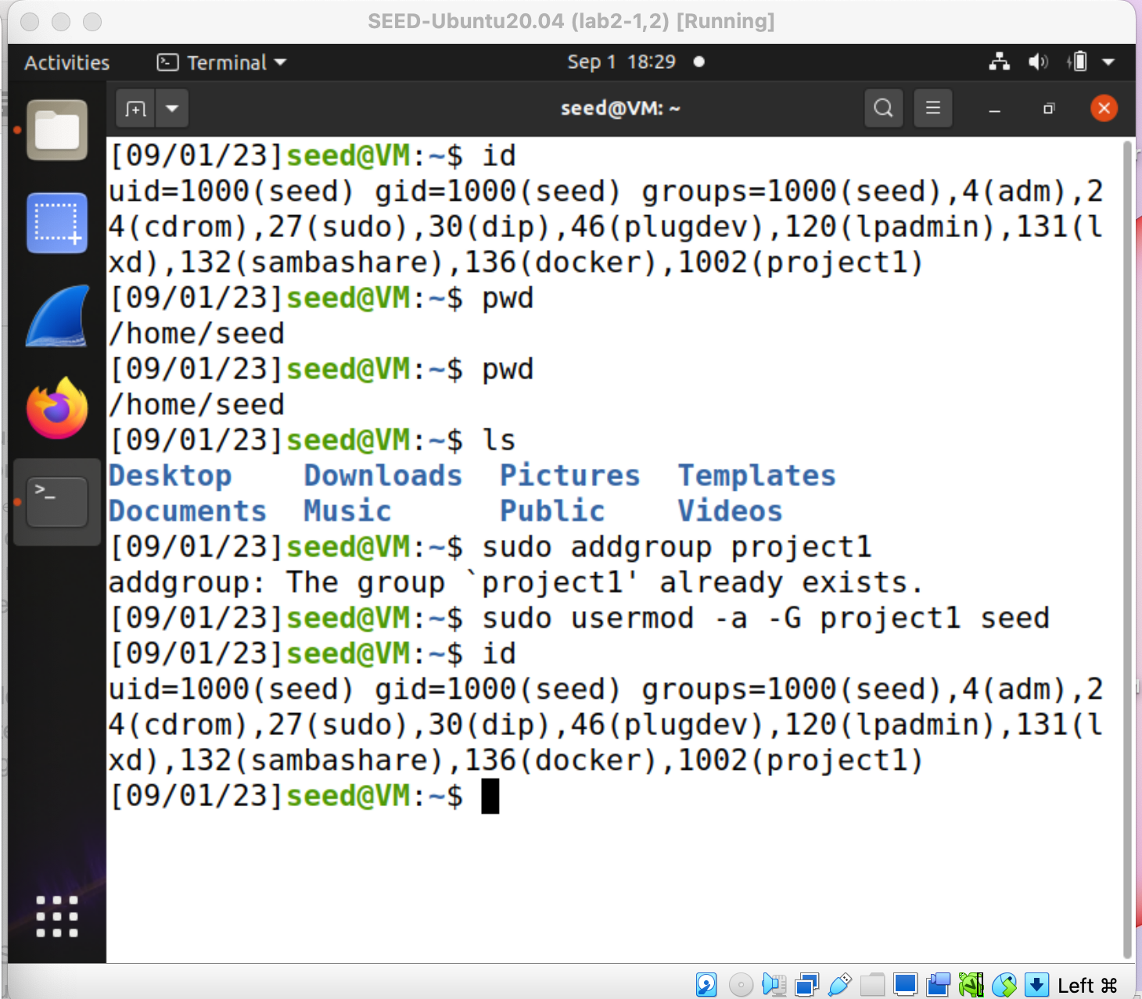

2.Create new user user1 and add it to project1 group too.

create new user 'user1'

-> sudo adduser user1

add user1 to project1

-> sudo usermod -a -G project1 user1

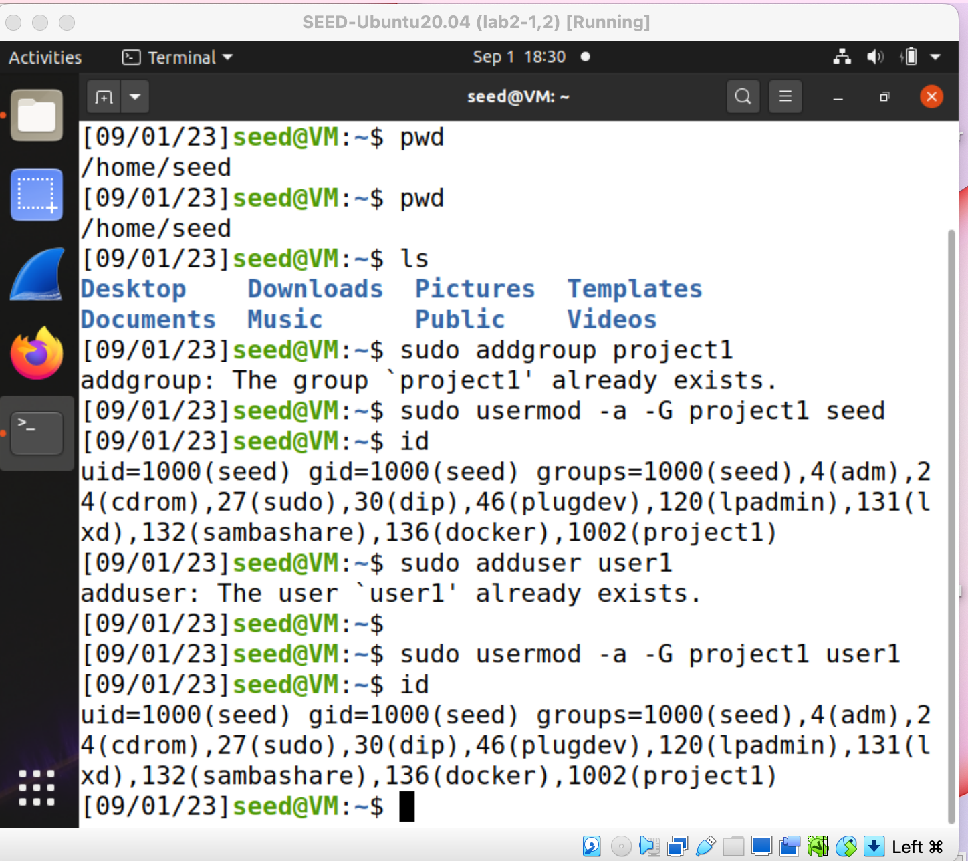

3.Create directory project1 under /home (i.e., /home/project1). Set its owner and group to seed and project1, respectively. Set its permission such that owner and group have full access (read/write/execute), and others have no access.

set owner and group permission to 770 so that owner and group have full access to this directory but others do not have read write execute access.

Set project1 directory's owner as seed and group as project1.

-> sudo chown seed:project1 project1

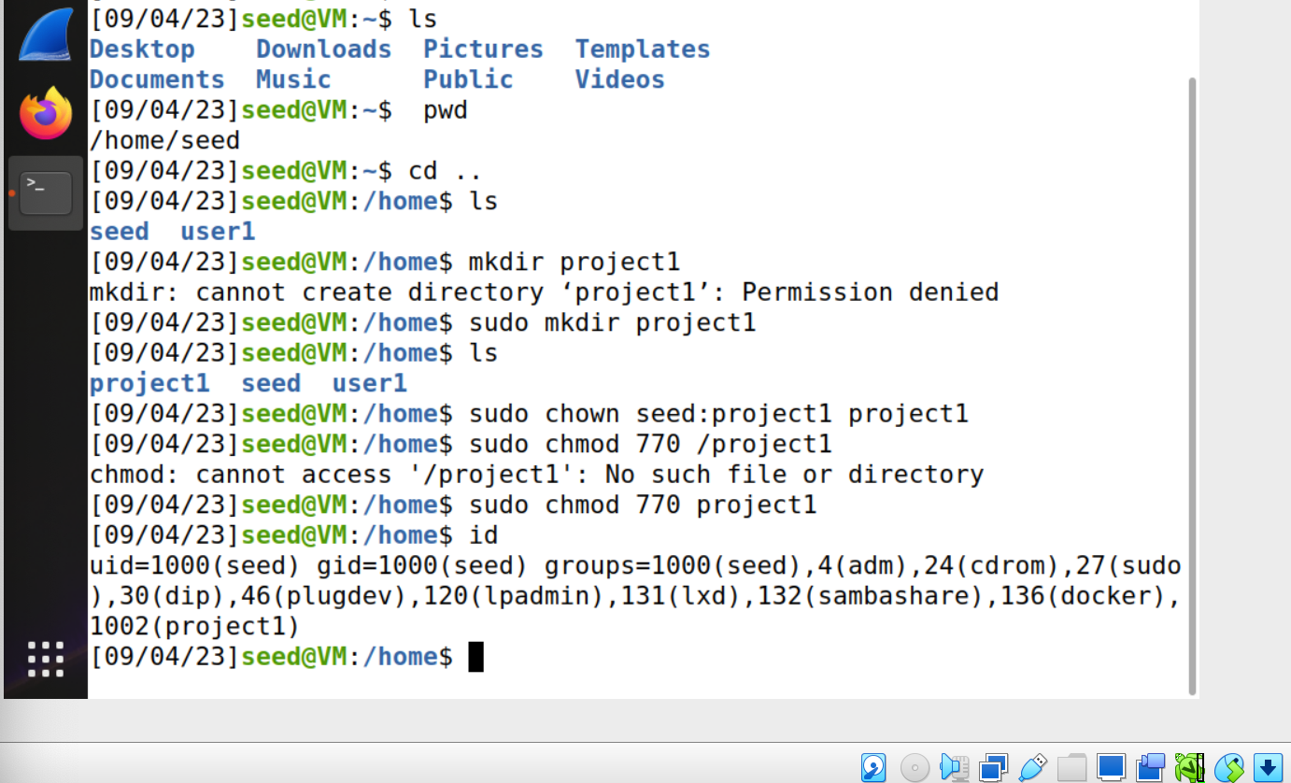

4. Set your umask to 0027. Explain what you expect this to achieve.

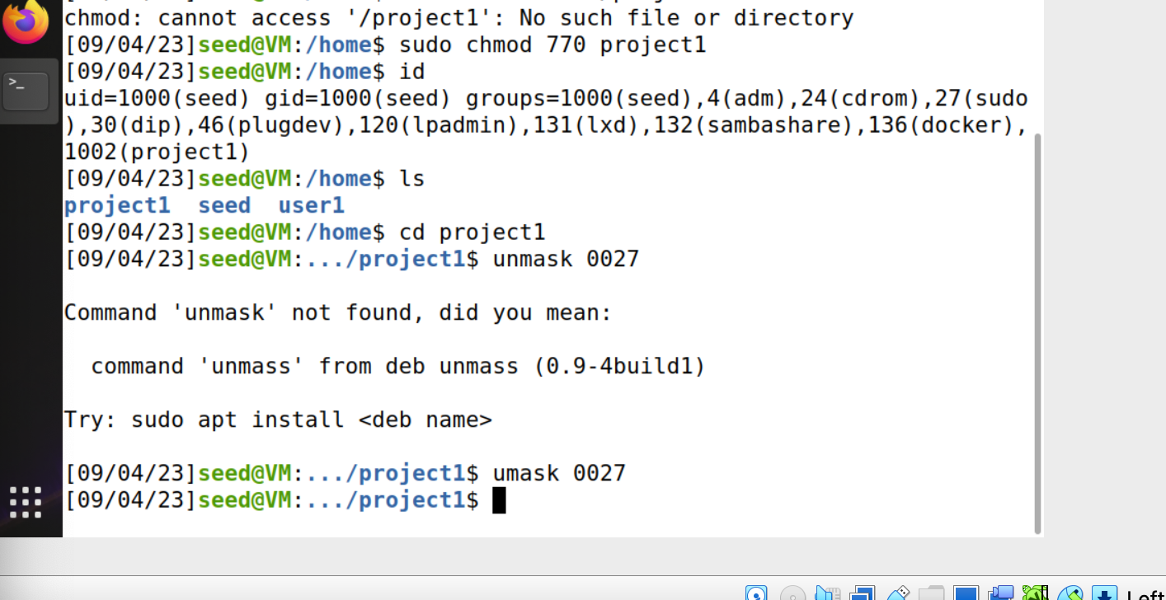

I used umask 0027 to give file access permission to the owner as 0 ( unable to read/write/execute) group as 2( only able to write) and other as 7 ( read write execute available).

5. Download the latest Pro Git book as your first document in the project folder via the following command:

wget -P /home/project1 --no-check-certificate <https://github.com/progit/progit2/releases/download/2.1.407/progit.pdf>

Downloaded Pro Git book in /home/project1

I used given command line to download progit.pdf file in project1 directory.

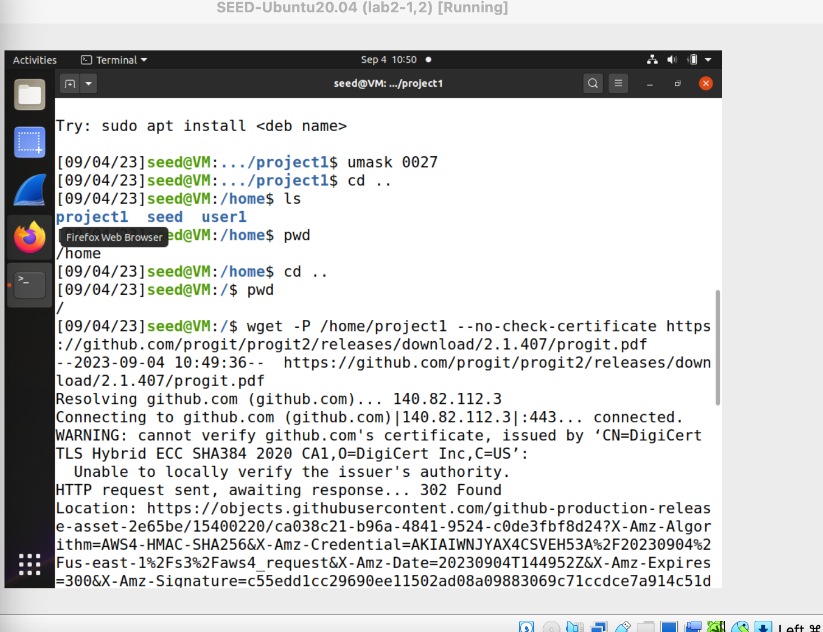

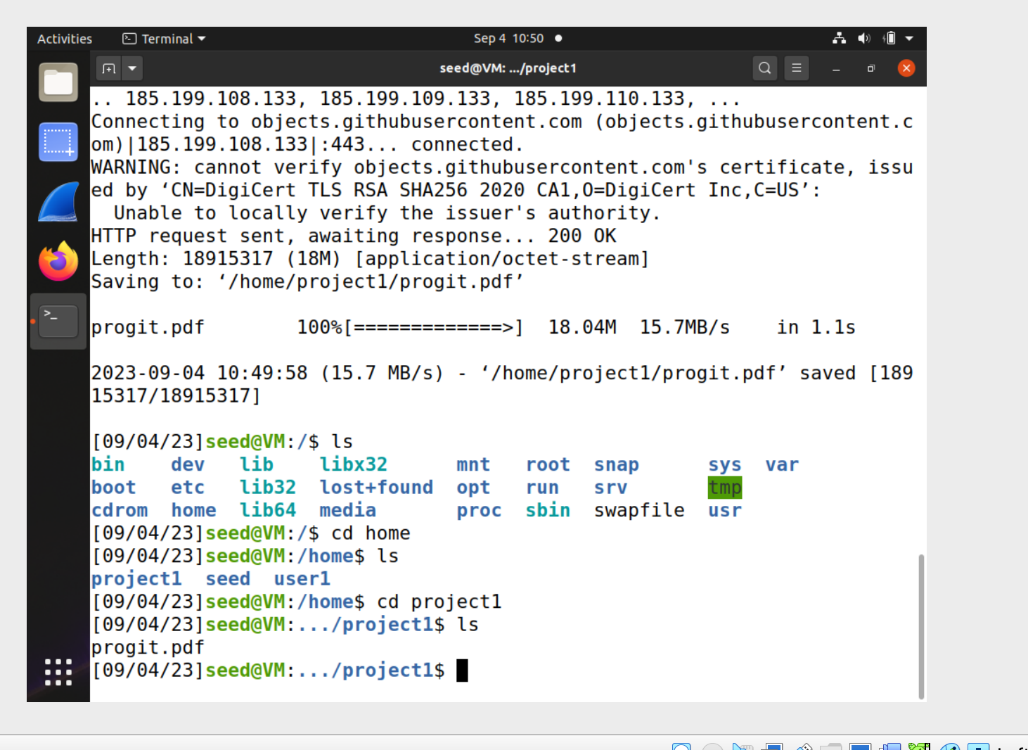

6. Switch user to (or log in as) user1. Try copying the downloaded file /home/project1/progit.pdf to /home/user1 and report the result. Discuss why.

I am unable to copy progit.pdf as user1. Because directory folder project1 is setted permission to owner and group to access this folder as read/write/execute. Other’s permission is not allowed for read/write/execute. Therefore, user1 is unable to download the file or copy the file.

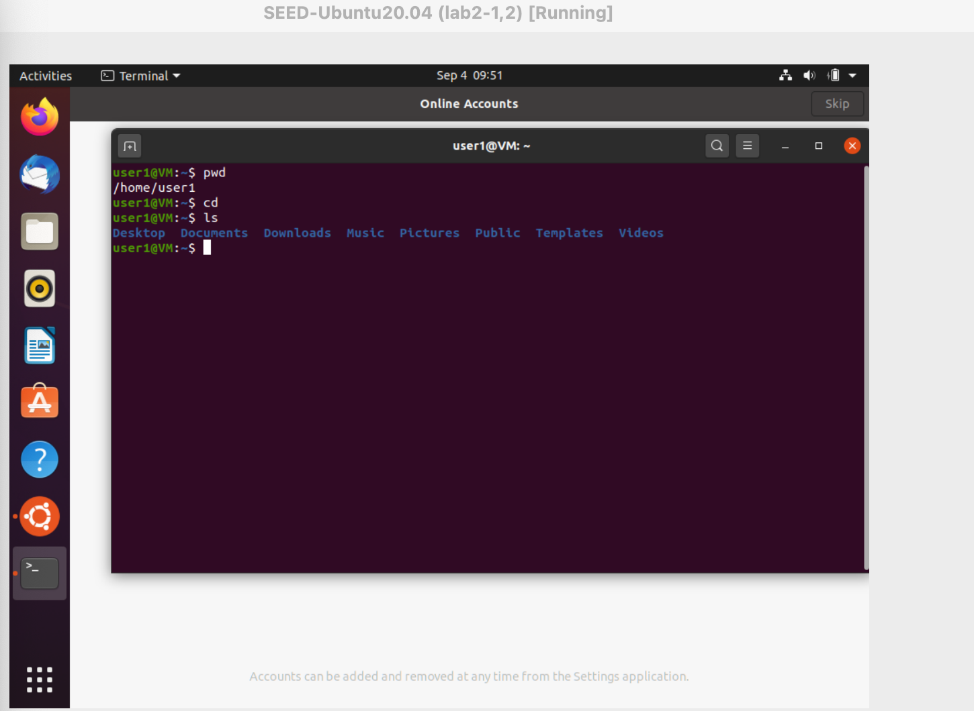

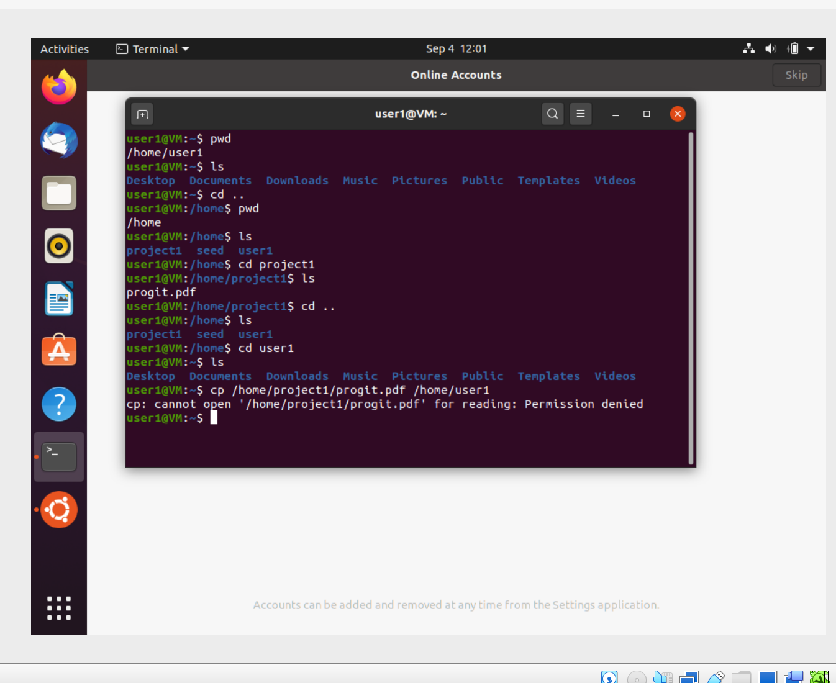

# As we can see above, access was denied because there was no permission for user1 to copy the progit.pdf file.

7.Switch back to user seed. Can you change the properties of the downloaded file so that it will be accessible to user1 too? Once done, verify it by retrying Step 5.

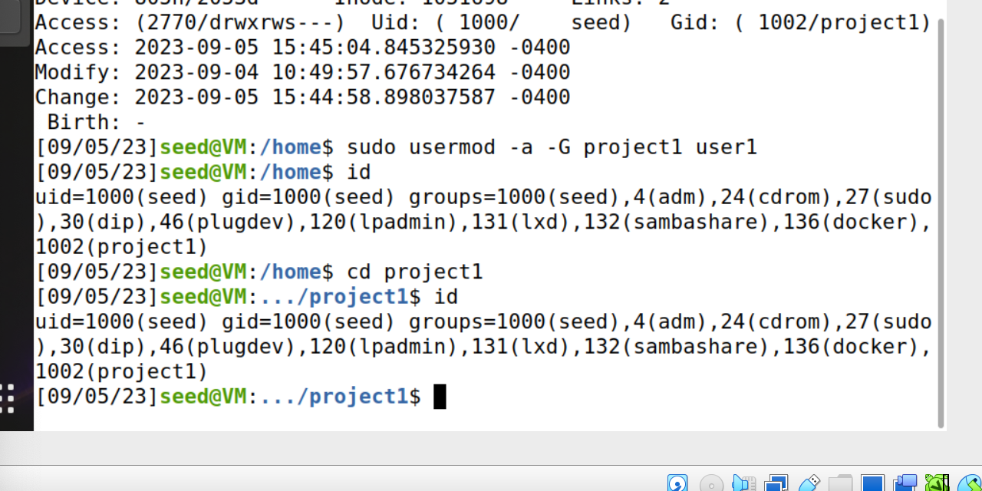

# instead of setting permission of project1 file to 777 permission, I added user1 into group project1. Since group project1 has full access to the project1 directory. This way user1 can access the project1 folder.

And then Change file owner and/or group using chown command line so that group project1 can access downloaded file named as progit.pdf. Since user1 is in group project1. User1 can access to progit.pdf.

->Sudo chown :project1 project1/progit.pdf

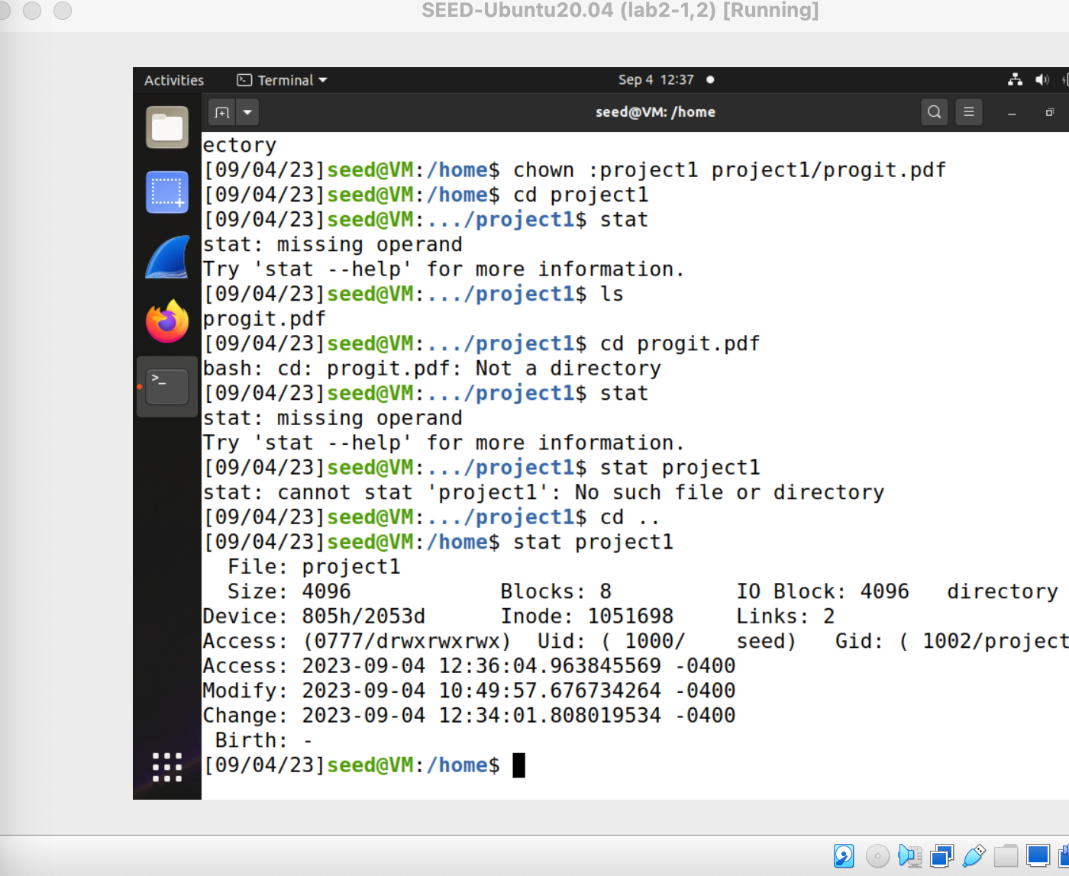

## add user1 into group project1. So if there is a file that accessible as group project1 then user1 can also access to it.

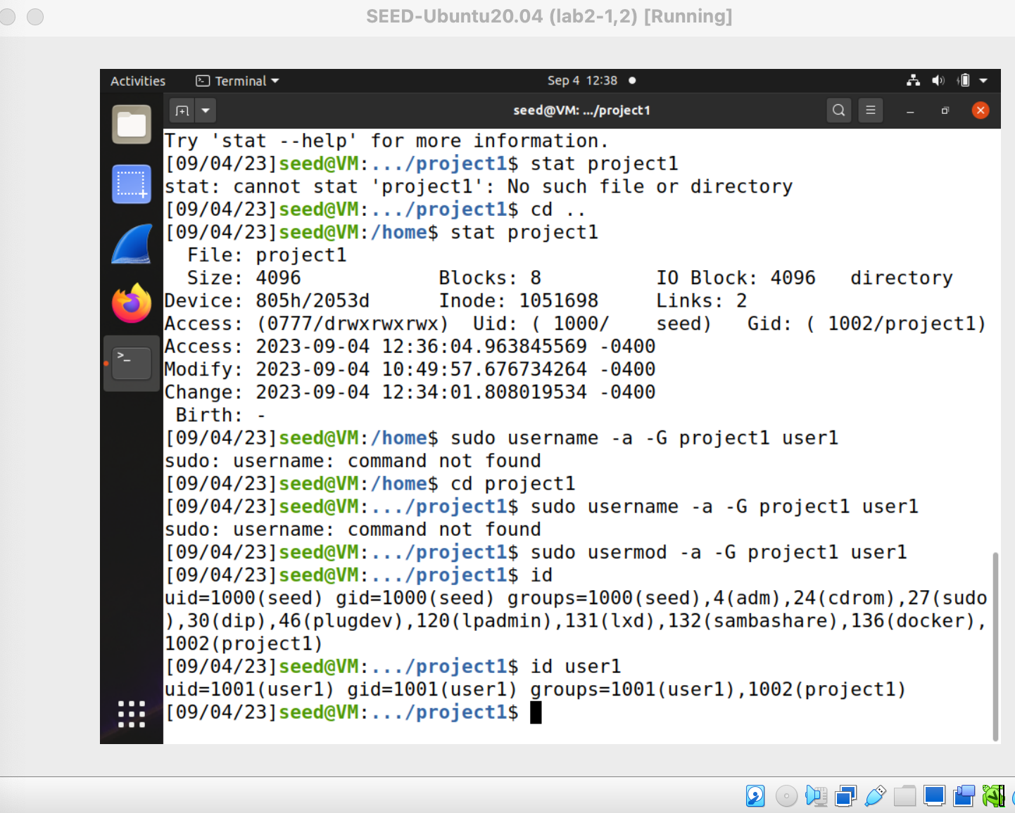

# check whether user1 is added to group named project1

# log in as user1 and see

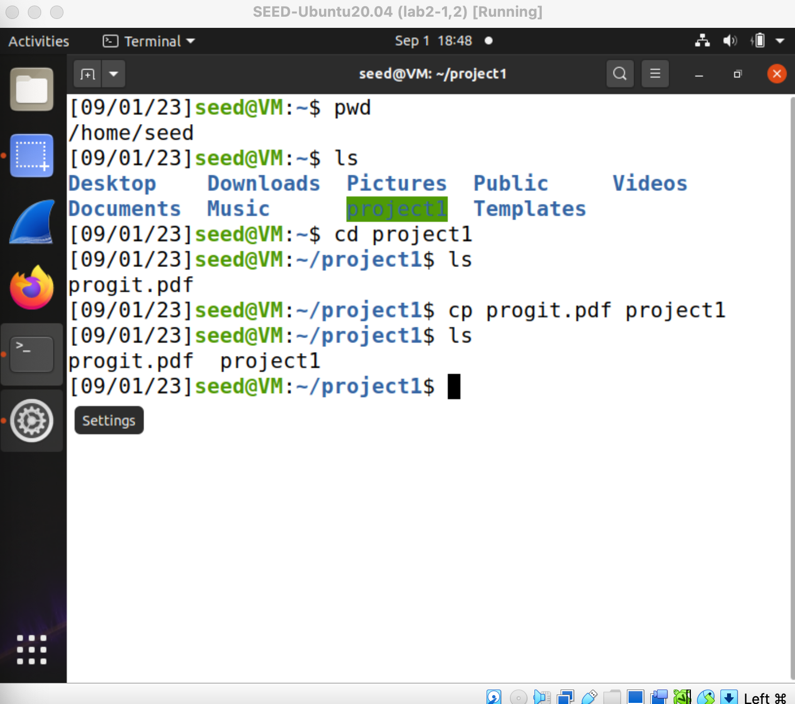

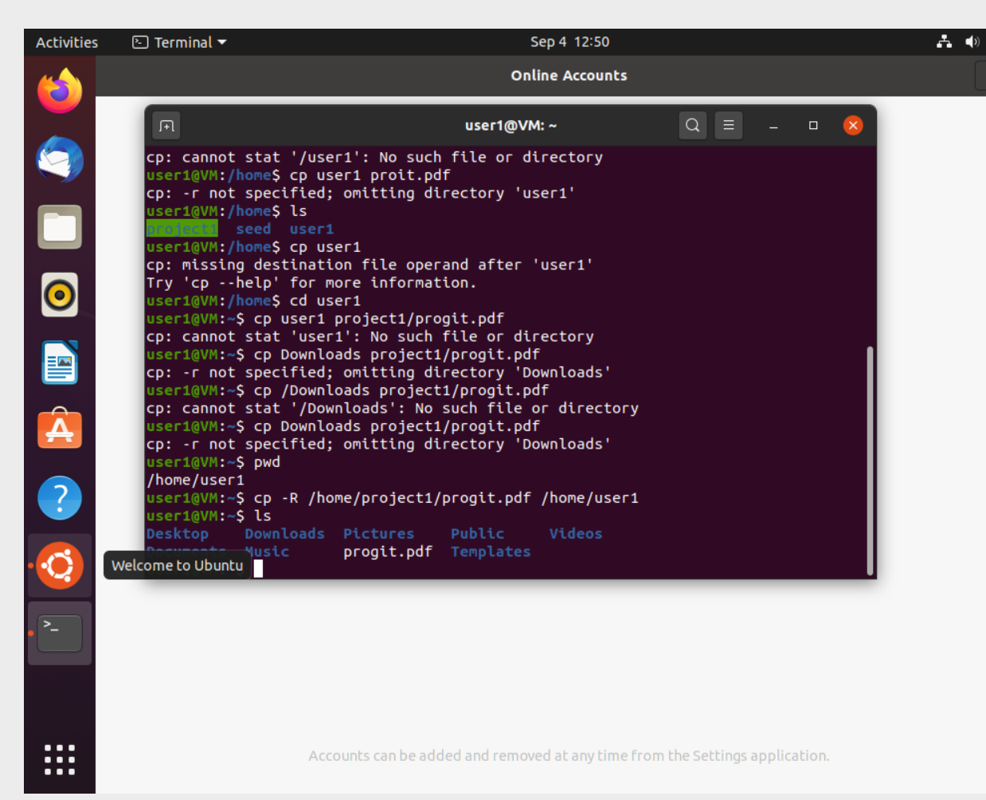

# Download progit.pdf on user1

8.Research how you can ensure that future files created in /home/project1 will be available to project1 members (not everyone) without needing to change ownership explicitly for every downloaded file. Implement it and verify the result by deleting and re-downloading the book above.  
Hint: You need to set a special permission for the directory.

I will delete the download progit.pdf file from part 6.

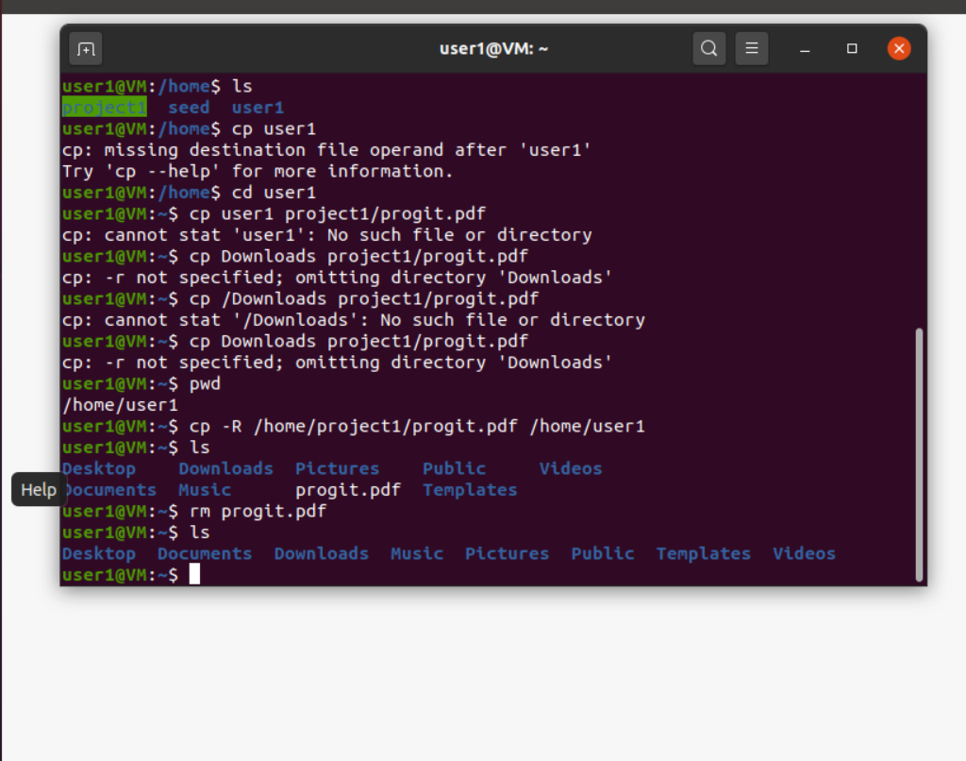

-> log out as user1 and log in as seed to change permission for directory project1

-> umask 002 # this will allow group to able to write

-> chgrp project1 project1 # this will set project1 directory to group project1

-> chmod g+s project1 # directory project1 will be with group named as project1

So all project1 groups can access.

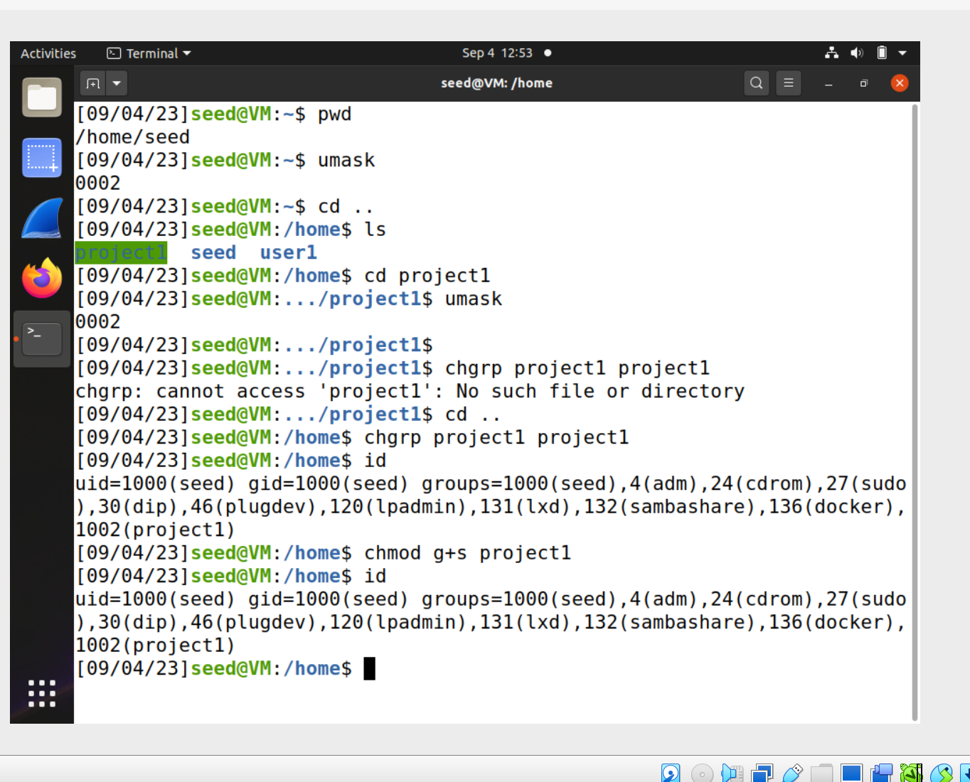

# download progit.pdf as user1 again.

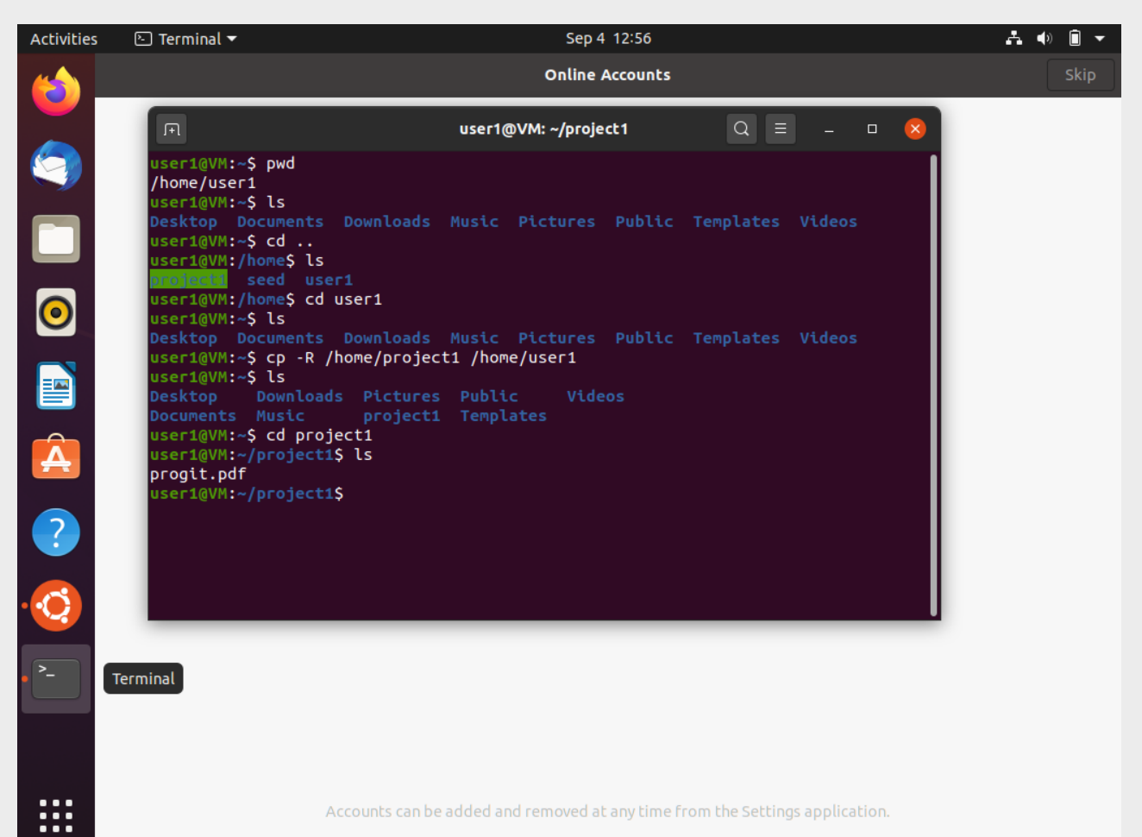

# The above terminal shows that I could download the project1 directory to user1 and I was still able to access the copy progit.pdf file.